# Evidence of good collaboration

## Good communication and file sharing

Receivable evidence includes:

* Emails and other types of messages (Facebook messenger, WhatsApp etc.)
* Screenshots of Basecamp conversations in which you actively participate.
* Screenshots showing files (designs, reports) that **you** shared with your team on Basecamp

***Important****: Please include no more than 5 items*

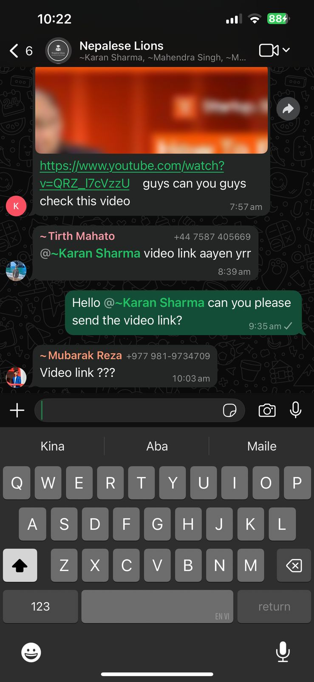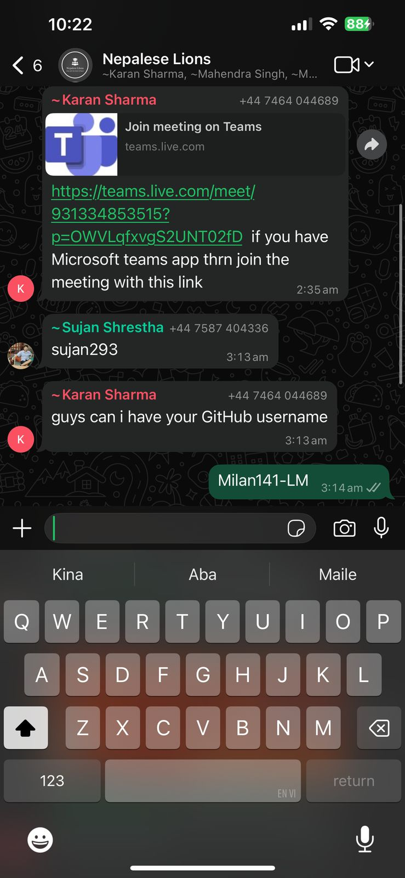

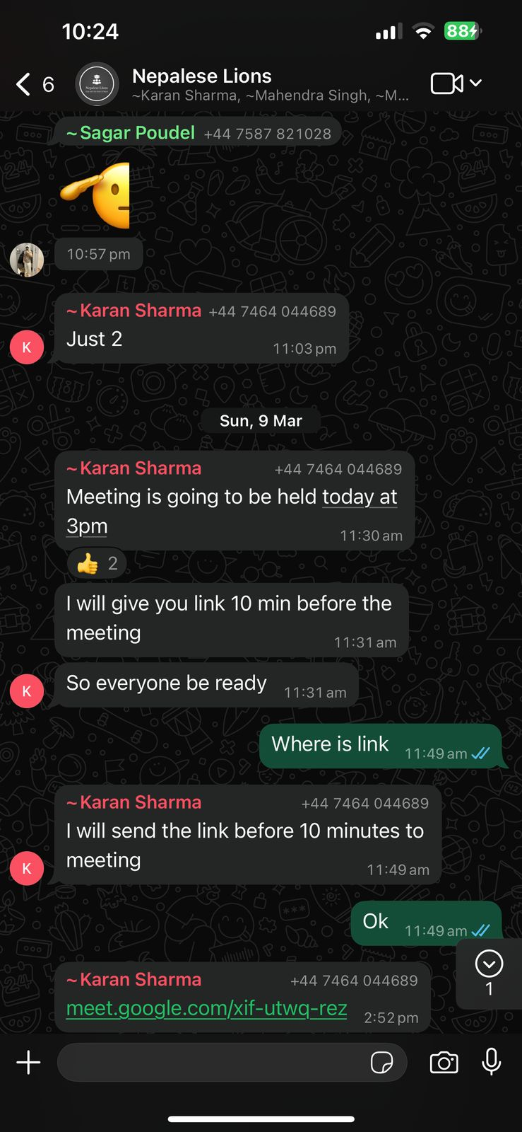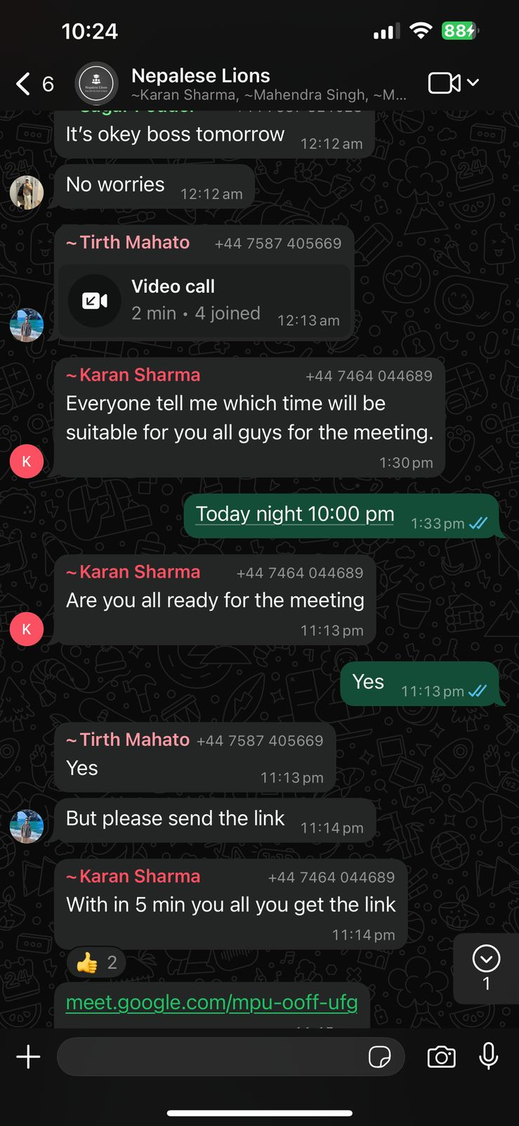

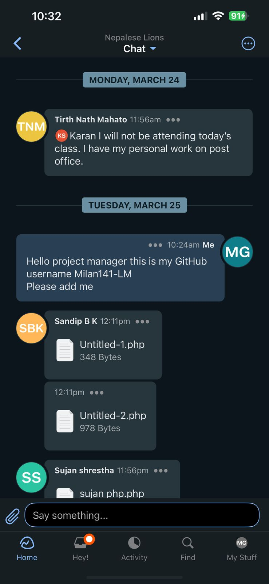

**Continuing Personal Development (CPD)**

Receivable evidence includes:

* Course/seminar attendance register
* Online course: certificate of completion
* Word document summarising what was learnt and how it can be used on the project

***Important****: Please include no more than 5 items*

## Issue tracking

Receivable evidence includes:

* Screenshots of **personal contributions** to GitLab issues.

***Important****: Please include no more than 5 items*

## Work to deadlines

**No evidence required**. Your tutor will decide whether you have worked to deadlines based on various factors (team meetings, discussions with other team members, discussion with client etc.)